

1.INTRODUCTION

1.1 A brief description about your projects.

Let us analyze the Indian agriculture crop production for the data collected from 1997 to 2022. Let us ask interesting questions on existing data get production and aarea statistics and understand more on the Indian agriculture history for crop production.

1.2 the use of this project.what can be achieved using this.

Agriculture is the foundation of the Indian economy.the population of india mostly dependes on agriculture for their livelihood and agriculture contributes to 40% of the total GDP of the country

2.problem definition and design thinking 2.2 Paste the empathy map screen short

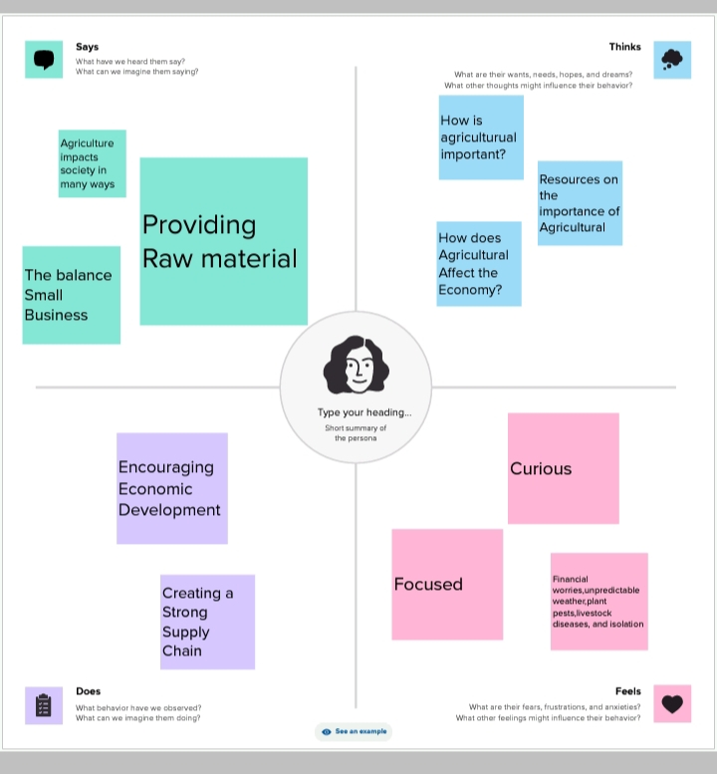

2.2 BRAIN STORM AND IDEATION

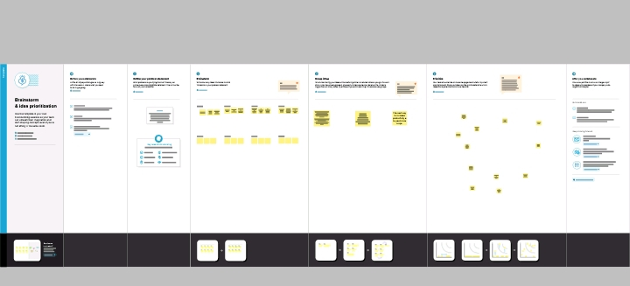

3. Result

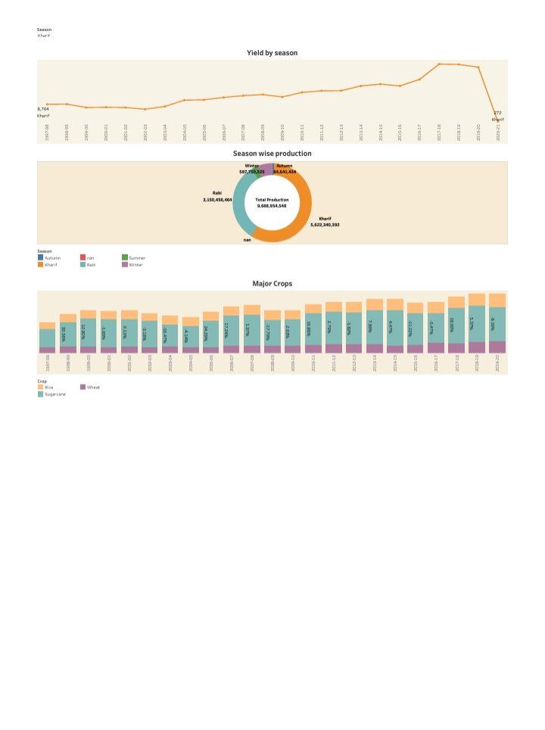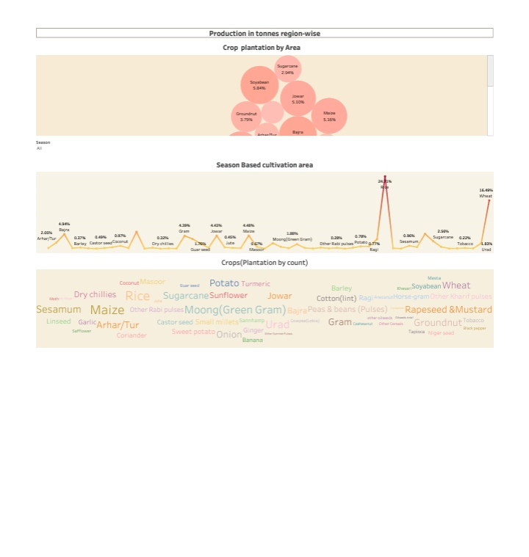

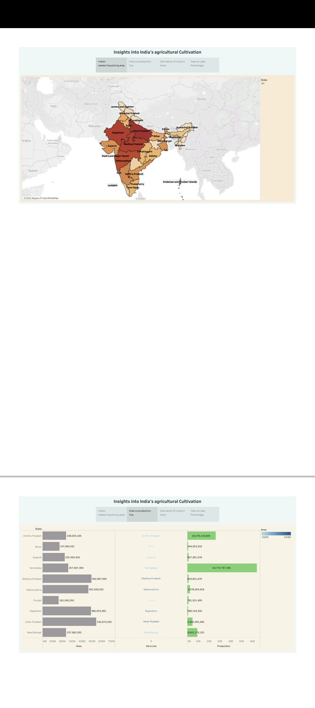

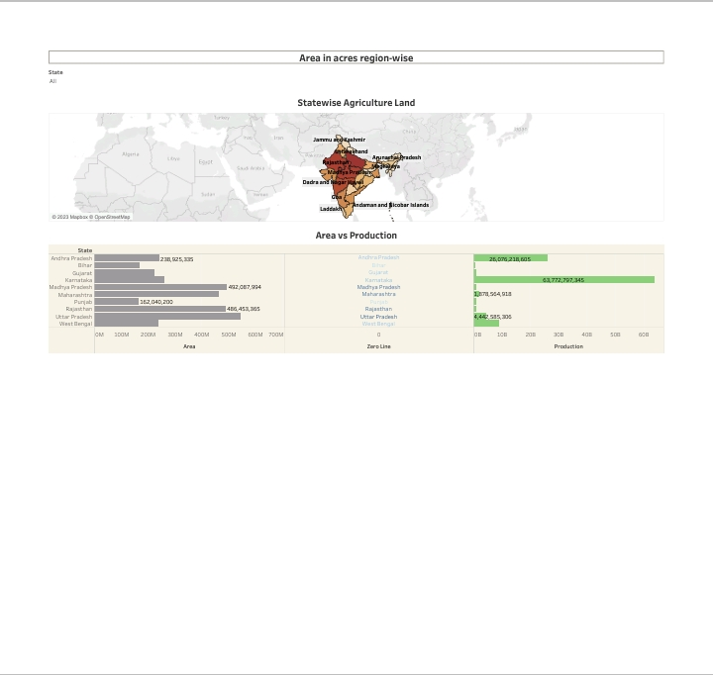

4 ADVANTAGES AND DISADVANTAGES

|  |  |
| --- | --- |
| ADVANTAGES | DISADVANTAGES |
| Improved crop quality | Bio diversity loss |
| Reduced Environmental Impact | Water pollution |
| Increased to food production | Health risks |
| Economic benefits | Food safety concerns |

5 APPLICATIONS

Indias arable land area of 159 .7 million hectares is the second largest in the world after the united status. Rice is sown the largest area in india.

6 CONCLUSION

Agriculture is the art and science of cultivating the soil , growing crops , and raising livestock.Agriculture provides most of the worlds food and fabrics.

7 FUTURE SCOPE

Future agriculture will use sophisticates technologieas such as roborts ,temperature and moisture sensors ,aerial images , and GPS techonology.